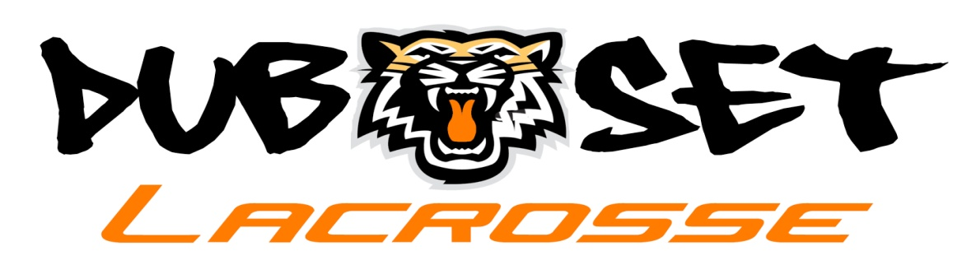
Mark Armogida 914-907-9925 Howie Rubenstein 914-659-3199
www.dubsetlacrosse.com

Boy's Registration Form
Dubset Summer Lacrosse Club-Application 2017

Name:

Address:

Date of Birth: Position:

Home Phone: Player’s Cell #

Parent Email:

School:

Parent
Signature:

US Lacrosse
Membership # (Players must be a US Lacrosse member…you can sign up at www.uslacrosse.org cost is $25)

Shirt Size (Please Circle) Shorts Size (Please Circle)

S M L XL S M L XL

Please mail application and $400 deposit ASAP to hold your roster spot.
Checks made payable to “Tiger Sports”.
Send to:

Mark Armogida
9 Quincy Lane
White Plains, NY 10605

